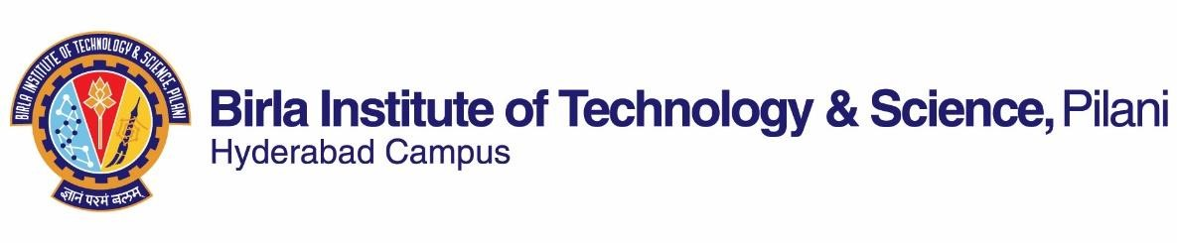

**SECOND SEMESTER 2019-2020**

# Course Handout Part II

Date: 16-1-2023

In addition to Part-I (General Handout for all courses appended to the time table) this portion gives further specific details regarding the course.

*Course No.* : HSS F335

*Course Title* : Literary Criticism

*Instructor-in-Charge* : Shilpaa Anand

**Scope and Objectives of the Course:** The course introduces the student to various trends in critical analysis and critical thought from the Classical period to the modern context. The student will identify and distinguish shifts in literary criticism and analyse a text based on the different critical approaches. The course will enable the student to describe and explain various aspects of a specific critical approach in relation to the historical context in which it emerged.

The main objectives of the course are to:

* introduce students to the theory and practice of literary criticism;
* enable students to analyse a literary text using different critical approaches;
* enable students to describe and explain the historical context and conceptual basis of different critical approaches

**Textbooks:**

1. Barry, Peter. 2018. *Beginning Theory: An Introduction to Literary and Cultural Theory*. Manchester: Manchester University Press.

**Reference Books:**

1. Habib, M. A. R. 2005. *A History of Literary Criticism: From Plato to the Present*. Malden, MA: Blackwell.
2. Waugh, Patricia. 2006. *Literary Theory and Criticism.* Oxford: Oxford University Press.
3. Klarer, Mario. 2013. *An Introduction to Literary Studies*. London: Routledge.

**Course Plan:**

|  |  |  |  |
| --- | --- | --- | --- |
| **Lecture No.** | **Learning objectives** | **Topics to be covered** | **Chapter in the Text**  **Book** |
| 1-4 | Describe literary criticism and identify different aspects of a literary text | Key concepts: LITERATURE; LITERARY CRITICISM | Additional material will be made available |
| 5-8 | Identify and describe classical Greek notions of poetry and their influences on literary criticism | MIMESIS: Plato and Aristotle | TB: Chapter 1; Select portions from RB 1 and RB 2 |
| 9-13 | Identify and distinguish between different trends in criticism between the 17th and 18th centuries | LITERATURE AND THE EUROPEAN ENLIGHTENMENT: literature, nationhood, ‘rights’ debates: Dryden, Johnson and Wollstonecraft | Select portions from RB 1 and RB 2 |
| 14-16 | Discuss the main ideas that emerged during the period of Romanticism | Theories of IMAGINATION: Wordsworth and Coleridge | Select portions from RB 1 and RB 2 |
| 17-19 | Describe and discuss the shifts in late 19th-century and early 20th-century criticism | LITERATURE AND MORALITY: Mathew Arnold and his influences | TB: Chapter 1; Select portions from RB 1 and RB 2 |
| 20-24 | Describe and distinguish Marxist and psychoanalytic approaches to literature | MATERIAL AND SOCIAL CONDITIONS OF LITERARY PRODUCTION | Select portions from RB 1 and RB 2 and RB 3 |
| 25-28 | Identify different literary aspects of a text and use the *close-reading* method to discuss a literary text | TEXTUAL ANALYSIS OF LITERATURE: poetry and short fiction; T.S.Eliot and his influence on British and American critics | Select portions from RB 1 and RB 2 and RB 3 |
| 29-32 | Comprehend  structuralist and poststructuralist approaches to studying literature | Theories of the ‘AUTHOR’ and the ‘READER’: Barthes and Foucault | TB: Chapter 3; Select portions from RB 1 and RB 2 and RB 3 |
| 33-37 | Discuss feminist criticism, Black feminist criticism, postcolonialism and queer theory | CONTEXTUAL ANALYSIS OF LITERATURE: gender, region, race, caste, sexuality | Chapter 6 Select portions from RB 1 and RB 2 and RB 3 |
| 38-40 | Describe late 20th century approaches to studying ‘literature’ | LITERATURE, CINEMA AND POPULAR CULTURE | Select portions from RB 1 and RB 2 and RB 3 |
| 41 |  | Course Overview and Revision |  |

**Evaluation Scheme:**

|  |  |  |  |  |
| --- | --- | --- | --- | --- |
| **Component** | **Duration** | **Weightage (%)** | **Date & Time** | **Nature of Component** |
| Assignment 1 | TBA | 15 | TBA | Open Book |
| Mid-Semester Examination | 90 minutes | 25 | 15/03 2.00 - 3.30PM | Closed Book |
| Assignment 2 | TBA | 15 | TBA | Open Book |
| Comprehensive Examination | 180 minutes | 45 | 13/05 FN | Closed Book |

**Chamber Consultation Hour:** To be announced in class and on CMS.

**Notices:** Notices concerning the course will be displayed on CMS or other platforms as notified.

**Make-up Policy:** Make-up exams and make-up assignments will be granted due to medical reasons if students have prior clearance from institute authorities and if students have informed the instructor beforehand. If a student has an extraordinary situation that does not allow him/her to appear/ for the examination/submit an assignment, the student is responsible for intimating the matter to the instructor at the earliest.

**Academic Honesty and Integrity Policy**:

Academic honesty and integrity are to be maintained by all the students throughout the semester and no type of academic dishonesty is acceptable.

**Shilpaa Anand**

**INSTRUCTOR-IN-CHARGE**